**Task 5**

**The Colleague**

**Group:**

Kyle Bostelman – Full Jared Perry - Full Andrew Dzierla - Full Jeffrey Kimmel –Full

Brett Galloway – Full

As a member of the team, I attended this meeting at the time set by the group leader. We further discussed how our application should function while creating some prototypes of our system. I collaborated with team members by helping with drawings of interfaces and decisions on the looks and features, along with functionality and flow of the application.

**Application Overview:**

The colleague application is a cellular device application, available through the app store. The application is portable and flexible, while at the same time allowing for complete device attention. This means that there is no need to view an address bar nor any other menus that are present on the browser window. The user only sees what is intended for them to see. The user is first required to login to their student account, which will then take the information from the school’s student database. The application will take this information acquired to populate the personal account information within the application. Once logged in, the application has a default view that shows a graphic representation of the entire college, with the ability to zoom in to a specific location. The red dot representations on the map view indicate meeting locations that are either occurring or scheduled to occur within the next thirty minutes. A ‘+’ button in the lower right hand corner is a button used to open the new meeting window, where the user can create a meeting. Also, the user can change their view by the click of a tab in the top toolbar. The feed view is a more information driven view that clearly expresses what is occurring that is relevant to the user. This uses interests as well as personal information, to filter all groups, meetings, and need help tutor sessions to the ones that are relevant. At all times the user can open a menu window in the top left hand corner that shows a list of options. The first option is profile, where the user can view and change account information. The second option is settings, where the user can change settings of the application. The third option allows the user to find help with problems they could be having with the app. The last option is log out, which will bring the view back to the login screen. The application also possess a level of security that is sufficient to keep delicate student and instructor information safe and secure. The user is able to use this application to achieve the goals of finding particular people to share their interests, at the same time ensuring their safety and security by requiring every user to be listed as either a student or instructor at the institution. The application is also able to display all users that certain filters can be applied to. The overall size of the application seems small and familiar, but possess a complex and efficient back end that supplies all levels of functionality.

**Personas**

In all versions of the application, the personas below would still be able to accomplish their needs and desires of the system.

**Persona #1:**

Name: Jim Somename

Role: College Student

Major: Computer Science

Jim is enrolled in an online class through his current institution, and has a group project approaching. Jim has posted several posts looking for a group on the class discussion board, yet no one has messaged Jim to add him to their group. He could have logged onto this application and searched his current class. The search would reveal everyone would is looking for a group in the class and everyone who has already posted a group in the class. This allows Jim an easier approach at not only finding a group for the project, but a group that fits more of Jim’s interests and career goals. This application would empower Jim to gain more from the group project in knowledge, grade, and even meaningful lifelong connections.

**Persona #2:**

Name: Frank Anothername

Role: College Student

Major: Women Studies

Frank is not only a student, but an athlete for his current institution. Frank would like to find another student at his current school to practice fielding balls in baseball. He would be able to log onto the application and post a group or meeting specific to his sport. Because of this post, Jim who had interest in batting practice could respond to the group or meeting post by Frank. This would make a great connection between two passionate athletes interested in bettering their athletic abilities. In turn this would make the college’s baseball team more skillful.

**Requirements**

The application achieved all functional and non-functional requirements.

**Functional Requirements of the Application:**

* Restrict access to either student or instructor at the specific college.
* Create and manage virtual and real meetings.
* Create and manage groups of users.
* Add the user to a selected group or meeting.
* Store and present user’s personal information.
* Allow changing of user’s personal information.
* Present a visual representation of the campus.
* Represent particular meetings as visual representations.
* Present a live feed of current information regarding groups and meetings.
* Allow admin to control content of the application.
* Allow admin to monitor all groups and meetings.

**Non-Functional Requirements of the Application:**

* Keep the size of the application compact and simple.
* Ensure application is capable with most modern cellular devices.
* Limit the data that would be used for updating unless connected to a wireless network.
* Ensure the application is accessible cross platform.
* Make the application easily updatable to include more functionality as the need arises.
* Allow for easy transformation into a desktop or web application.

**UML Use Case**

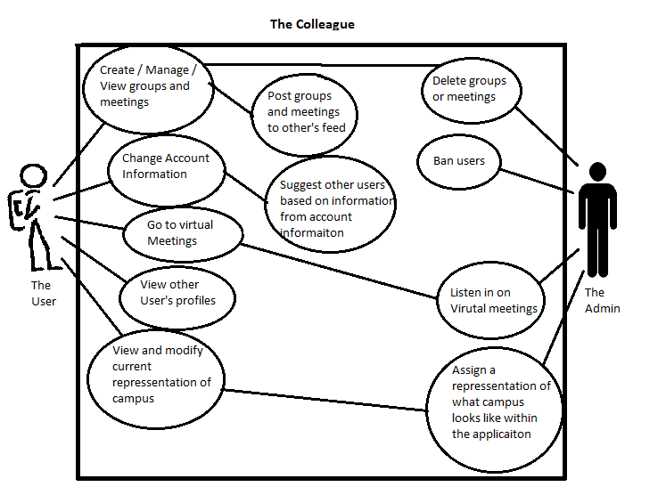

**Prototypes:**



**Login Screen:** The user logs into their account using this familiar format.



**Map View:** The user has the map button on the top toolbar depressed. The red dots represent meetings, and the ‘+’ button is the option to add a meeting.



**Create Meeting Window:** The user can add a meeting by supplying the title of the meeting, the location, the description, and the users and groups the meeting should be associated with.



**Hamburger Menu:** A view that shows the options of profile settings, application settings, a help option, and an option to log out to the login screen.



**Feed View:** Displays all personal meetings and group posts under the personal header. Shows all needs help tutor meetings, which are related to the user’s personal interests. Also, shows a general feed with college meetings and postings.